keywords | Volume | KD
Pre owned luxury watches | 590 | 22
best luxury watch brands | 2.4k | 28%
best watch brands | 12.1 | 29%
best watches for men | 9.9k | 25%
best luxury watch brands for men | 1.3k | 28%
mens luxury watches | 5.4k | 31%
luxury men watch | 3.6k | 29%
best luxury timepieces | 320 | 25%
luxury timepiece brands | 260 | 28%
best luxury watch brands for ladies | 880 | 28%
pre owned luxury watches for sale | 110 | 25

Meta Title:
World best Pre owned Luxury Watches | Swiss Ice
Meta Description:
Explore the largest collection of certified Pre owned luxury watches of Rolex, Cartier, Patek Philippe, Omega, and many more brands for sale at fair prices.

Pre Owned Luxury Watches (h1)
Level up your timepiece collection with our gorgeous, meticulously selected collection of pre owned luxury watches exclusively at Swiss Ice. We have a stock of the best luxury watch brands at much lower prices than the market standard.

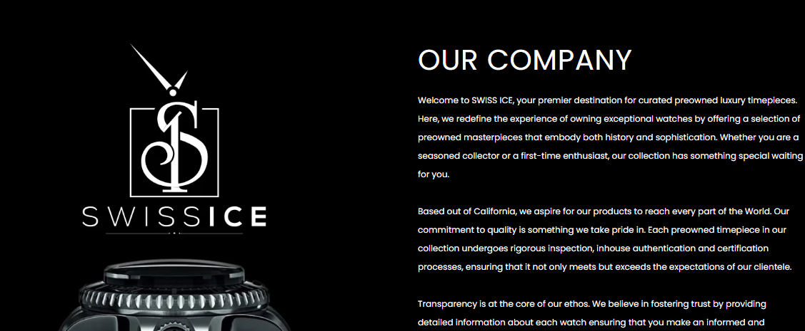

OUR COMPANY (h2)

Swiss Ice is your one-stop shop of choice for exquisite Pre owned luxury watches. It is our pleasure to present to you more beautifully crafted timepieces of the perfect blend of history and elegance to alter your expectations of owning a luxury watch.

Whether you are an experienced collector or just a beginner, Swiss Ice is your ultimate source of information about the best luxury watch brands for men and women. We are proud to mark our initial starting point in California where we are established with the aim to ship out our carefully selected pre-owned watches worldwide.

Quality is not something that is declared by Swiss Ice: it is something that we guarantee. Every single one of our luxury men's watches goes through verification, identification, and authentication before being shipped out to fulfill our requirements and your expectations. We boast about our commitment to creating trust by considering the essential criterion of transparent work and give you comprehensive information about each watch model to allow you to make a proper choice.

So, why wait any longer? Come with us on this thrilling ride and find out what certified pre-owned luxury watches are to be found for you. Here at Swiss Ice, you can get any watch you ever dreamed of!

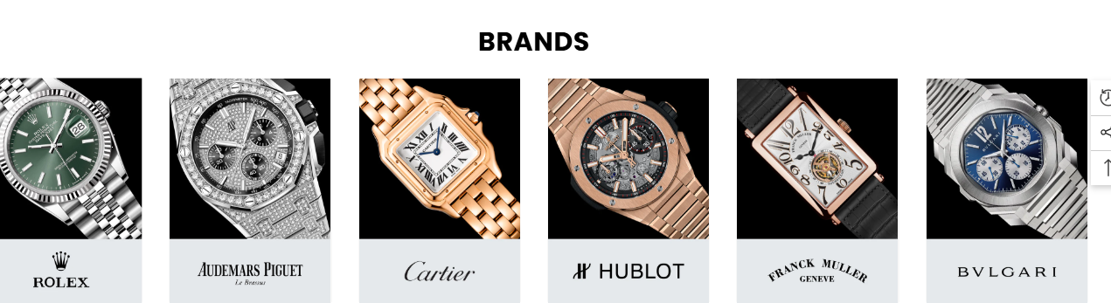
Best Watch Brands (h2)

Browse through our large collection of the best watch brands. Beginning from the traditional-looking Rolex and Omega watches to the modern-styled Rolex, Cartiers, Hublot and Breitling watches, we have it all. Check out our catalog of the best luxury timepieces and discover the model, which will perfectly complement your personal taste.
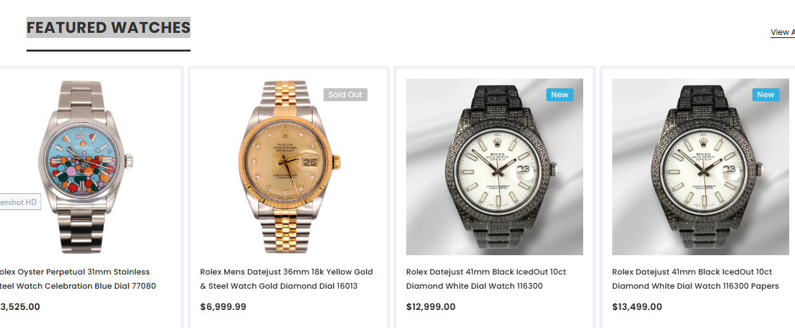

Our Exclusive Watch Collection (h2)
Are you searching for pre owned luxury watches for sale? See our selection of used luxury timepiece brands watches that we offer for sale. Each watch is selected by our team to guarantee you the best quality and the best finishing touch. Our store specializes in every possible style and theme, representing both affordable and luxury prices.

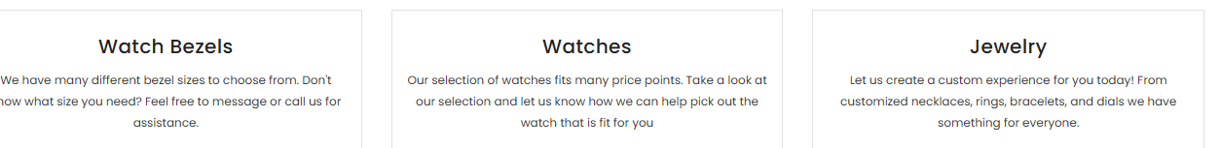

Watch Bezels | Watches | Jewelry
Please browse our extensive collection of the best watch brands, ranging from traditional-looking Rolex and Omega watches to the modern-styled Hublot and Cartiers. | With Swiss Ice, the best luxury and rare timepieces have become more accessible than ever before. Explore our collection to find the best-fit watch for you. | Explore our wide collection of beautiful jewelry items such as pendants, bracelets, necklaces, and rings. Make a style statement daily with glamour and elegance.

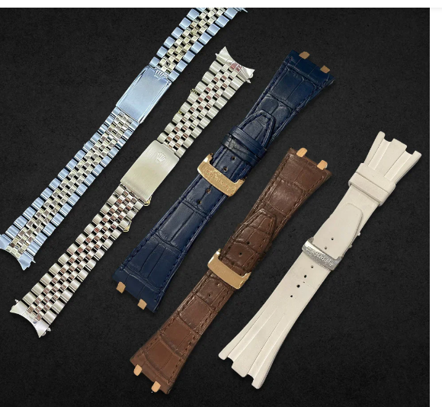
Note: The content will be used in place of the image, and the image will be removed.

Mens Luxury Watches Every Occasion (h2)
If you are searching for mens luxury watches then our wide range of pre-owned luxury watches will make a perfect fit. Regardless of whether you want to buy men's watches for casual wear, formal wear or special events, we have a perfect piece for each moment. At Swiss Ice, we hold a large collection of timepiece models for both male and female customizers suitable to their unique personalities.

FAQ's

Are all of the watches you sell authentic? (h3)
Yes, every wristwatch that we sell at Swiss Ice is subjected to rigorous testing to check on its quality and authenticity.

Can I visit the Swiss Ice showroom? (h3)
Yes, our showroom is open for visitors, and our staff is always ready to help you to choose a proper luxury watch for you.

How do you set the price of a second-hand watch? (h3)
Our watch experts consider different factors such as the age of the watch, the condition, and the brand, as well as market demand, to determine the price of a watch. You can be assured that all the prices we offer at our facility are reasonable and quite affordable.

Do you give warranties on your watches? (h3)
Of course, for all the used watches that we offer, we offer a 30-day money-back guarantee on your purchase.

What payment methods are acceptable by Swiss Ice? (h3)
We use credit cards, PayPal, and bank transfers to process payments from our customers.

How soon can I expect to get the watch that I bought online? (h3)
It is our goal to dispatch your product(s) within 1-5 business days from the date of your order from our warehouse location.
